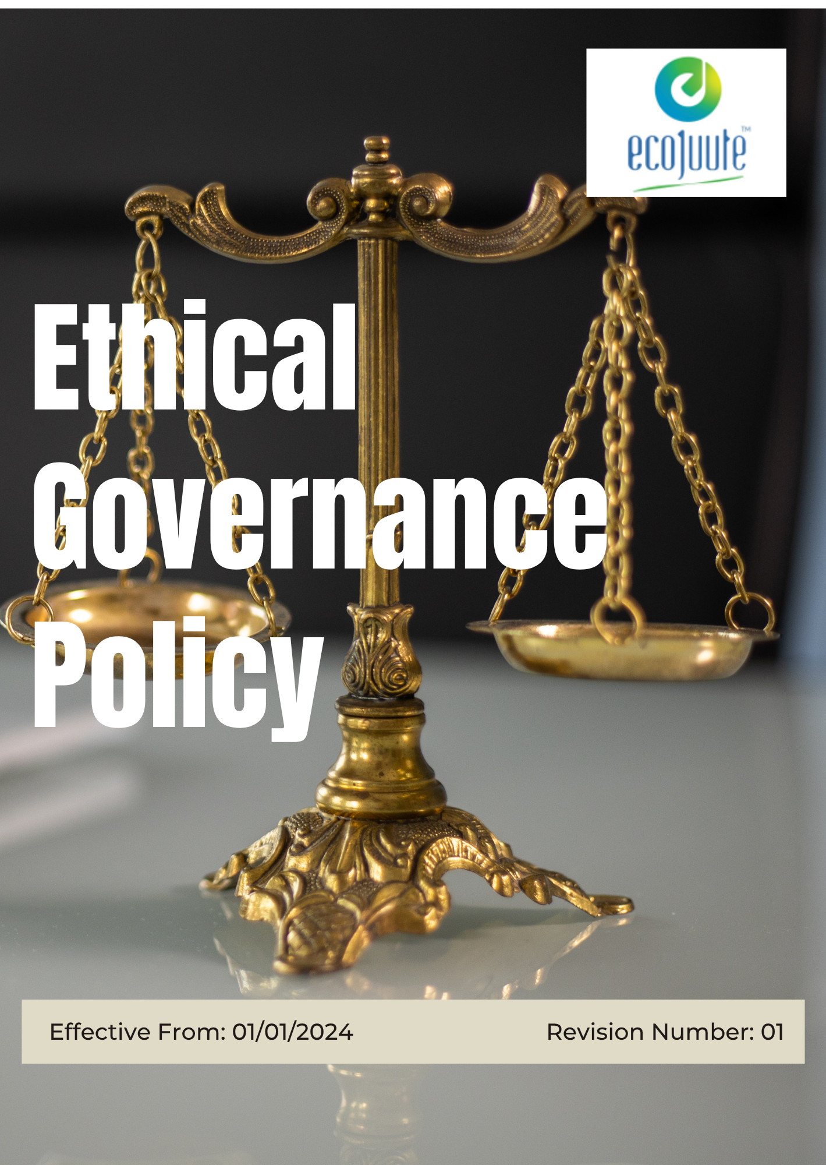

INDEX

1. Our Policy Statement 3
2. Our Approach 3
3. Scope 3
4. Our Ethical Governance Commitment 4
5. Our Ethical Governance Targets 5
6. Ethical Conduct: What to Do and What to Avoid 7
7. How to Raise a Concern 10
8. Responsibility 11
9. Reporting Section 12
10. Consequences for Violation of this Policy 13
11. SDG Alignment 15
12. Review Mechanism 15
13. Employee Acknowledgement: Ethical Governance Policy 17

Our Policy Statement
Eco Jute Pvt. Ltd. is committed to conducting business with integrity, transparency, accountability, and ethical conduct. The Company has zero tolerance for bribery, corruption, fraud, conflicts of interest, and other unethical practices.
Employees, suppliers, contractors, and business partners are expected to comply with applicable laws and the Company’s ethical standards. Eco Jute Pvt. Ltd. promotes responsible decision-making, confidential reporting of concerns, and appropriate action against identified violations to maintain trust and accountability across its business operations

Our Approach
Eco Jute Pvt. Ltd. integrates ethical considerations into its business and procurement processes alongside cost, quality, reliability, and delivery requirements.

The Company establishes clear ethical standards to prevent bribery, corruption, fraud, conflicts of interest, and other unethical practices. Employees, suppliers, and business partners are expected to comply with these standards and applicable laws.

Through awareness, monitoring, reporting mechanisms, and continual improvement, Eco Jute Pvt. Ltd. promotes transparency, accountability, and responsible business conduct across its operations and supply chain.

Scope
This policy applies to all employees, contractual workers, contractors, and other personnel of Eco Jute Pvt. Ltd., as well as relevant suppliers, service providers, and business partners.

It covers business activities involving ethical conduct, anti-bribery and anti-corruption, conflicts of interest, fraud prevention, Information Security, responsible decision-making, reporting of concerns, and compliance with applicable laws and Company requirements.
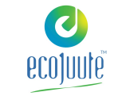 | ECO JUTE PVT. LTD.
Address:
- 6th Floor, Kankaria Estate, 6, Little Russel St, Kankaria Estates, Park Street area, Kolkata, West Bengal 700071
- Gokna Basudevpur, P.O Jadurhati, P.S- Baduria, District - 24 Parganas (North), Pin Code – 743293
 | https://www.ecojuteindia.com/contact.html

Our Ethical Governance Commitment
Eco Jute Pvt. Ltd. is committed to maintaining high standards of integrity, transparency, accountability, and responsible business conduct across its operations and business relationships. The Company’s ethical governance commitment covers the following key focus areas:

- Anti-Bribery and Anti-Corruption: Maintain zero tolerance for bribery, corruption, kickbacks, facilitation payments, and other improper business practices.
- Conflict of Interest: Promote transparent decision-making and require actual or potential conflicts of interest to be disclosed and appropriately managed.
- Fraud Prevention: Maintain effective controls to prevent, identify, and address fraud, misappropriation, falsification, and other fraudulent activities.
- Ethical Business Conduct: Promote honesty, fairness, transparency, accountability, and compliance with applicable laws and Company requirements.
- Whistleblower and Grievance Management: Provide appropriate channels for reporting ethical concerns and protect individuals who raise concerns in good faith from retaliation.
- Information Security: Protect confidential and sensitive Company and stakeholder information from unauthorized access, misuse, loss, disclosure, or alteration.
- Ethical Risk Management: Identify, assess, monitor, and mitigate significant ethical and compliance risks and take corrective action where concerns are identified.
- Employee Awareness: Provide relevant training and awareness to employees and other applicable stakeholders to strengthen understanding of ethical responsibilities.

Our Ethical Governance Targets
- Establishes 2023 as the Baseline year for measuring progress and achievements in our initiatives.

- Anti-Bribery and Anti-Corruption:
- Maintain zero tolerance for bribery, corruption, kickbacks, facilitation payments, and improper business advantages.
- Promote transparent and ethical business practices across all business activities.
- Provide anti-bribery and anti-corruption training to 100% of relevant employees annually through 2030.
- Conduct ethical due diligence for 100% of identified high-risk third parties before engagement through 2030.
- Review 100% of reported bribery or corruption concerns through the established investigation process within timeline through 2030.

- Conflict of Interest:
- Promote transparent decision-making and disclosure of actual or potential conflicts of interest.
- Ensure identified conflicts are appropriately assessed and managed.
- Obtain conflict-of-interest declarations from 100% of relevant employees and management personnel annually by 2030.
- Review and document 100% of declared conflicts of interest and implement mitigation measures where required by 2030.

- Fraud Prevention:
- Maintain zero tolerance for fraud, misappropriation, falsification, and other fraudulent activities.
- Strengthen internal controls to reduce fraud risks.
- Review 100% of reported fraud concerns through the established investigation process within timeline through 2030.
- Implement corrective actions for 100% of confirmed fraud-related control weaknesses within timeline through 2030.
- Conduct at least one fraud risk review annually through 2030.

- Ethical Business Conduct
- Promote honesty, fairness, transparency, accountability, and responsible decision-making.
- Ensure employees and business partners understand and follow the Company's ethical standards.
- Obtain Code of Conduct acknowledgement from 100% of employees by 2030.
- Provide ethical business conduct training to 100% of relevant employees annually through 2030.
- Screen 100% of critical suppliers and business partners against defined ethical requirements by 2030.

- Whistleblower and Grievance Management
- Maintain accessible and confidential channels for reporting ethical concerns.
- Protect individuals who raise concerns in good faith from retaliation.
- Review 100% of reported ethical concerns within timeline through 2030.
- Conduct an initial assessment of 100% of significant complaints within 48 hours through 2030.
- Track corrective actions for 100% of confirmed cases until closure through 2030.

- Information Security
- Protect Company, employee, customer, supplier, and business information from unauthorized access, loss, misuse, disclosure, or alteration.
- Promote responsible handling of confidential and sensitive information.
- Provide information security awareness training to 100% of employees annually through 2030.
- Review access rights for 100% of critical systems annually through 2030.
- Review and assess 100% of reported significant information security incidents through 2030.
- Disable information system access for 100% of separated employees through the established exit process through 2030.

- Ethical Risk Management and Monitoring
- Identify and manage significant ethical, corruption, fraud, and compliance risks.
- Strengthen ethical governance controls based on assessments, incidents, audits, and stakeholder feedback.
- Conduct an ethical and corruption risk assessment at least annually through 2030.
- Conduct at least one internal review of ethical governance controls annually through 2030.
- Track and close 100% of identified corrective actions within defined timelines through 2030.

Ethical Conduct: What to Do and What to Avoid
1. Anti-Bribery and Anti-Corruption

Do
- Follow the Company’s anti-bribery and anti-corruption requirements.
- Report suspected bribery, improper payments, or unethical business practices.
- Ensure business transactions are properly documented and transparent.
Don’t
- Offer, promise, request, or accept bribes or improper payments.
- Make facilitation payments or provide benefits to improperly influence decisions.
- Conceal or falsify transactions or payment records.

2. Conflict of Interest
Do
- Disclose actual, potential, or perceived conflicts of interest.
- Seek guidance when personal interests may affect business decisions.
- Make decisions objectively and in the Company’s best interests.

Don’t
- Use your position for personal benefit.
- Participate in decisions where you have an undisclosed conflict.
- Conceal personal relationships or interests that may influence business decisions.
3. Fraud Prevention
Do
- Maintain accurate and complete records.
- Follow established financial and operational controls.
- Report suspected fraud or misuse of Company resources.
Don’t
- Falsify documents, expenses, records, or financial information.
- Misappropriate Company funds, assets, or resources.
- Conceal fraudulent activities or suspected misconduct.

4. Ethical Business Conduct
Do
- Act honestly, fairly, and professionally.
- Comply with applicable laws, regulations, and Company policies.
- Treat employees, customers, suppliers, and business partners respectfully.
Don’t
- Engage in dishonest, deceptive, or unethical business practices.
- Misrepresent information to customers, suppliers, employees, or authorities.
- Accept or provide inappropriate benefits intended to influence business decisions.

5. Whistleblower and Grievance Management
Do
- Report suspected misconduct through established reporting channels.
- Provide accurate information when raising a concern.
- Maintain confidentiality when handling reported concerns.
Don’t
- Ignore or conceal known ethical violations.
- Make knowingly false or malicious allegations.
- Retaliate against anyone who raises a concern in good faith.

6. Information Security
Do
- Protect confidential, personal, customer, supplier, and Company information.
- Use passwords, systems, devices, and information only for authorized purposes.
- Report suspected data breaches, unauthorized access, or information security incidents promptly.

Don’t
- Share passwords or confidential information with unauthorized persons.
- Access, copy, alter, or disclose information without authorization.
- Use Company information or systems for unauthorized or improper purposes.

7. Ethical Risk Management
Do
- Identify and report ethical and compliance risks.
- Follow established controls and corrective actions.
- Cooperate with internal reviews, investigations, and assessments.

Don’t

- Ignore known ethical or compliance risks.
- Bypass established controls or approval processes.
- Conceal non-compliance, incidents, or investigation findings.

8. Employee Awareness and Training
Do

- Participate in required ethics, compliance, and information security training.
- Understand and follow the requirements applicable to your role.
- Seek clarification when ethical requirements are unclear.
Don’t

- Ignore mandatory training or awareness programmes.
- Treat ethical requirements as optional.
- Continue a potentially unethical activity when guidance or clarification is required.

How to Raise a Concern
Eco Jute Pvt. Ltd. encourages employees, contractors, suppliers, and other stakeholders to report suspected bribery, corruption, fraud, conflicts of interest, unethical conduct, information security breaches, or other policy violations.
Reporting Process
- Identify the Concern: Clearly note the nature of the concern, relevant persons, dates, locations, and available supporting information.
- Report the Concern: Raise the concern through the Company’s designated reporting channels, including the Reporting Manager, HR Department, Compliance Officer, or Senior Management. Concerns may also be reported directly by email to hr@ecojutepvtltd.
- Maintain Confidentiality: Share information only with persons authorized to handle the concern.
- Investigation: The concern will be reviewed and investigated appropriately based on its nature and severity.
- Corrective Action: Where a violation is confirmed, appropriate corrective or disciplinary action will be taken.
- Protection from Retaliation: Eco Jute Pvt. Ltd. does not permit retaliation against anyone who raises a genuine concern in good faith.
What to Include in a Report
- Nature of the concern
- Date and location of the incident
- Persons or departments involved
- Relevant documents or evidence, where available
- Any immediate or potential impact
Employees and stakeholders are encouraged to report concerns promptly and in good faith.

Responsibility
- Senior Management
- Ensure effective implementation of ethical governance practices aligned with Eco Jute Pvt. Ltd.’s values, business objectives, and ethical standards.
- Provide appropriate resources to support ethics, compliance, training, risk management, and internal controls.
- Engage with relevant stakeholders and remain informed about applicable governance, legal, and ethical requirements.
- Oversee significant ethical, compliance, fraud, corruption, and governance risks and ensure appropriate controls and mitigation measures are implemented.

- Ethics Officer
- Support the implementation and oversight of governance policies, procedures, and internal controls.
- Coordinate ethics, compliance, anti-bribery, anti-corruption, and information security awareness programmes.
- Monitor adherence to Company policies, ethical standards, and applicable legal requirements.
- Periodically review governance policies and recommend updates based on regulatory developments, risk assessments, and organizational needs.
- Facilities and Operations Management
- Implement applicable governance, ethical, and compliance requirements within their respective operations.
- Identify and address operational risks that may affect ethical or regulatory compliance.
- Maintain a safe, secure, and well-managed workplace in accordance with Company policies and applicable requirements.
- Promptly report significant compliance, ethical, or operational concerns to the appropriate authority.

- Employees
- Follow the Company’s governance policies, procedures, Code of Conduct, and ethical standards.
- Perform duties honestly, fairly, responsibly, and in compliance with applicable laws.
- Report suspected bribery, corruption, fraud, conflicts of interest, unethical conduct, or other compliance concerns through established reporting channels.
- Participate in and complete required ethics, governance, compliance, and information security training.

Reporting Section
- Internal Reporting
- Relevant functions shall periodically review information relating to ethical conduct, anti-bribery and anti-corruption, conflicts of interest, fraud, compliance, information security, reported concerns, investigations, and corrective actions.
- Significant ethical risks, compliance findings, reported concerns, investigation outcomes, and corrective actions shall be reported to Senior Management periodically.
- Suspected bribery, corruption, fraud, conflicts of interest, unethical conduct, information security breaches, or other policy violations shall be reported through established internal channels and appropriately investigated.
- Findings from reviews, audits, investigations, and risk assessments shall be communicated to relevant functions and corrective actions shall be monitored until closure.

- External Reporting
- Eco Jute Pvt. Ltd. may communicate relevant ethical governance and compliance information to customers, business partners, regulatory authorities, certification bodies, investors, and other stakeholders, where appropriate.
- Required disclosures and regulatory submissions shall be prepared in accordance with applicable laws, regulations, contractual requirements, and recognized reporting practices.
- Information intended for external communication shall be reviewed by the responsible function to ensure accuracy, consistency, confidentiality, and appropriate supporting documentation.

- Stakeholder Engagement
- The Company shall communicate its ethical expectations to suppliers, contractors, and business partners and encourage responsible business conduct.
- Employees shall be encouraged to raise concerns, provide feedback, and suggest improvements relating to ethical governance and compliance.
- Stakeholder complaints, concerns, and allegations relating to unethical conduct shall be recorded, reviewed, and addressed through appropriate channels.
- Stakeholder feedback, investigation findings, and engagement outcomes shall be considered when reviewing ethical governance practices, controls, training, and risk management measures.

Consequences for Violation of this Policy
At Eco Jute Pvt Ltd, we take violations of our Ethical governance policy very seriously. All employees and stakeholders are expected to adhere strictly to the principles outlined in this policy. Failure to comply with the governance policy will result in appropriate disciplinary actions and measures to address the breach. The consequences for violations may include:

- Disciplinary Actions:

- For Employees: Violations of the Ethical governance policy by employees may result in disciplinary actions ranging from formal warnings to suspension or termination of employment, depending on the severity and nature of the breach. Repeat offenses or serious violations will be treated with increased severity.
- For Management and Senior Executives: Serious breaches involving management or senior executives may lead to removal from their positions, legal action, and termination of employment. The company will conduct thorough investigations to determine the appropriate course of action.

- Legal Consequences:

- For Illegal Activities: Any violations involving illegal activities such as fraud, corruption, or money laundering will be reported to the relevant authorities. Legal proceedings may be initiated, and individuals involved may face criminal charges, fines, and imprisonment as applicable under the law.

- Financial Penalties:

- For Contractors and Suppliers: Contractors and suppliers who violate the Ethical governance policy may face financial penalties, including termination of contracts, loss of business, and legal action to recover damages. We will ensure that contractual agreements include provisions for compliance and penalties for breaches.

- Corrective Measures:

- For All Parties: In addition to disciplinary actions, we will implement corrective measures to address the root cause of the violation. This may include additional training, process improvements, and revisions to policies and procedures to prevent future occurrences.

- Reputational Damage:

- For the Company and Individuals: Violations of the Ethical governance policy may lead to reputational damage for the company and individuals involved. We will take steps to mitigate any negative impact and restore trust through transparent communication and corrective actions.

- Review and Appeal:

- For Employees and Stakeholders: Individuals subject to disciplinary actions have the right to appeal decisions through established grievance mechanisms. We will review appeals fairly and impartially, ensuring that all parties have an opportunity to present their case.

SDG Alignment
 |  | 

Review Mechanism
- Annual Performance Review
- Eco Jute Pvt. Ltd. shall review its ethical governance objectives, targets, and key performance indicators at least annually, including ethics training, reported concerns, compliance, risk assessments, and progress against defined targets.
- Progress, significant risks, investigation findings, corrective actions, and improvement initiatives shall be reviewed through periodic Management Review Meetings.
- Key achievements, challenges, non-conformities, risks, and opportunities for improvement shall be evaluated and documented.

- Continuous Improvement
- Findings from audits, investigations, risk assessments, compliance reviews, employee feedback, stakeholder engagement, and performance monitoring shall be used to strengthen ethical governance practices.
- Corrective actions shall be established and monitored where ethical violations, compliance gaps, control weaknesses, or other governance concerns are identified.
- Eco Jute Pvt. Ltd. shall provide appropriate awareness, training, and guidance to improve ethical conduct and compliance.
- Ethical governance policies, controls, training programmes, and risk management practices shall be reviewed periodically and updated where necessary.

- Policy Review and Update
- The Ethics Officer shall review this Ethical Governance Policy at least once every two years, or earlier where significant changes occur in applicable laws, business operations, ethical risks, stakeholder expectations, or governance requirements.
- Any amendments shall be reviewed and approved by Senior Management before implementation.
- Approved revisions shall be communicated to relevant employees, contractors, suppliers, and other applicable stakeholders.
- Where significant changes are introduced, appropriate training and awareness activities shall be conducted to ensure effective implementation of the Policy.

- Revision History
Revision No. | Revision Date | Description of Change
00 | 01-01-2024 | Initial release of the Ethical Governance Policy
01 | 01-01-2026 | Added Section on Ethical Conduct: What to Do and What to Avoid, added a formal Revision History table

(Signature)
Approved By:
Designations:
Last Review Date: 01-01-2026 Next Review Date: 01-01-2027

Employee Acknowledgement: Ethical Governance Policy
I acknowledge that I have received, read, and understood the Ethical Governance Policy of Eco Jute Pvt. Ltd. I understand the Company’s commitment to integrity, transparency, accountability, ethical conduct, and responsible business practices.
I acknowledge that compliance with this Policy is mandatory and that it applies to employees and relevant business partners, contractors, suppliers, and other associated stakeholders. I understand my responsibility to follow the requirements of the Policy and promptly report any suspected violations or concerns through the established reporting channels.
I understand that failure to comply with the Policy may result in appropriate disciplinary or corrective action. I also acknowledge that the Policy may be periodically reviewed and updated, and I am responsible for remaining aware of applicable changes.
By signing this acknowledgement, I confirm my commitment to uphold the principles of ethical governance, responsible conduct, transparency, and accountability at Eco Jute Pvt. Ltd.

Employee Name: ______________________
Department: _______________
Date: _______________
Employee Signature: ____________________

